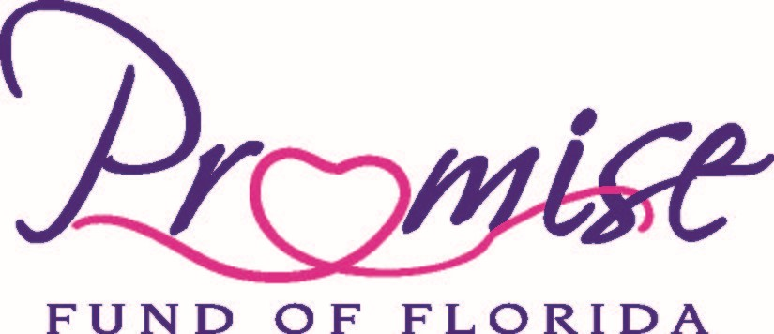

Presents

**Stop Cervical Cancer**

The Boynton Beach Arts & Cultural Center

125 E Ocean Ave**,** Boynton Beach, Fl 33435

**Saturday, January 7, 2023**

9:00 AM – 3:00 PM

# Vendor Registration Form

**Non-Profit Free; For Profit $250.00**

**Organization: _____________________________________________________________________**

**Contact Name: ____________________________________ Title: __________________________**

**City: ___________________________________________ State: ______ Zip: _______________**

**Tel: ___________________________________________ Fax: ____________________________**

**Email: __________________________________________________________________________**

**Type of Services or products Your Organization can provide –**

*________________________________________________________________________________________________*

__________________________________________________________________________________________________

## Number of People You Can Accommodate: ______________ Is Prior Registration Required? ◻ Yes ◻ No

Please provide a brief explanation of the type of Services or In-Kind Donations you will provide: ________________________________________________________________________________

*By signing below, I agree that the organization/business listed above will take part in the upcoming Stop Cervical Cancer: Get Vaccinated! Get Screened! Health Fair and will provide the stated services free of charge.*

**Signature: ____________________________________________ Date:___________________**

Please **return completed and signed form by January 2, 2023** via email to **info@mlcancerfoundation.org**

If you have any questions, please call **Judith Figareau at (561) 752-2122**

**413 W Boynton Beach Blvd · Boynton Beach, FL 33435**

**Tel: (561) 752-2122 · Fax: (561) 509-7046 · Cell: (561) 722-0076 · www.mlcancerfoundation.org**